**WEEK 3 - USING R VECTORS, MATRICES, DATA FRAMES, AND PLOTTING DATA**

**3.1 INTRODUCTION**

*This section has been read*

**3.2 LECTURE, PART 1: RECAP ON LAST WEEK, AND INTRODUCTION TO DATA STRUCTURES**

*Video has been watched*

**3.3 LECTURE, PART 2: MATRICES AND DATA FRAMES**

*Video has been watched*

**3.4 LECTURE, PART 3: PLOTTING DATA**

*Video has been watched*

**3.5 PRACTICAL PAGE**

*Practical has been carried out*

1. Show a list of the top 10 films

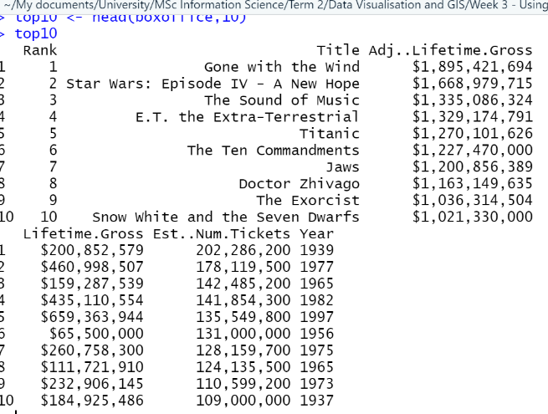

1. Show a list of film rank, title, and adjusted lifetime gross, in reverse order, from 20 to 11

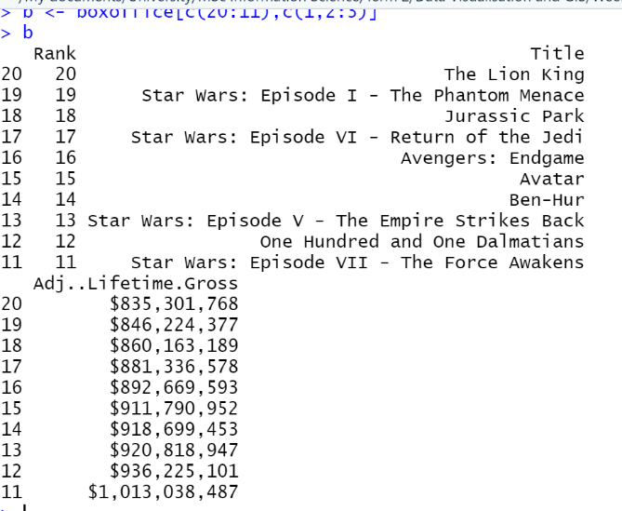

1. Create a logical index (see last week’s practical notes if needed) based on the boxoffice table, which is TRUE when the value of ‘Year’ is prior to 1960. Remember, you can refer to columns within a data frame using the dollar notation: boxoffice$Year

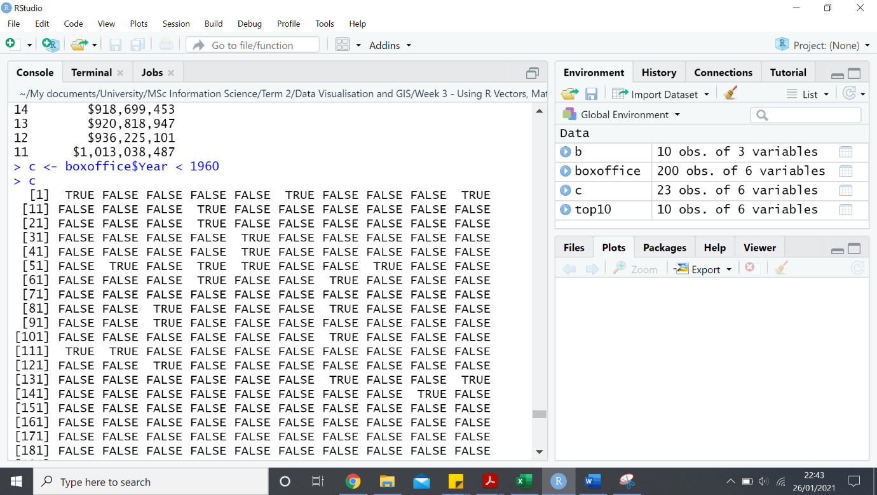

1. Use that logical index to list the details of the films in the all-time list that were released prior to 1960

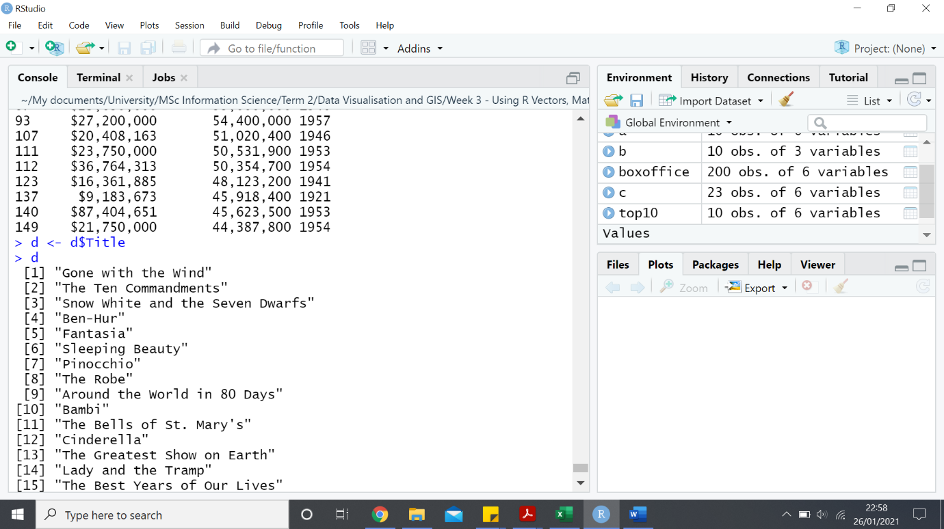

e) Use the notes from week 2 on pattern selection using grep to select films for which the title:

i. Matches the pattern “Star Wars” (anywhere in the title)

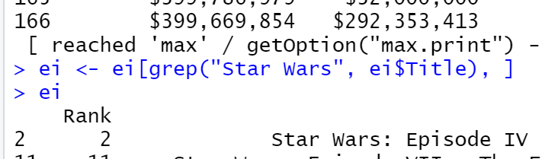

ii. Has a number at the end of the title (requires knowledge of regular expressions!]

Require solution

1. Require Solution
2. Require Solution
3. Require Solution

Need solutions for 26,27,28,29,30